Social Analytics (ISSS606) — Exam Reference Notes
Table of Contents
Social Analytics (ISSS606) — Open-Book Exam Reference Notes 3
SESSION 1 — Introduction & Graph Fundamentals 3
Key definitions 3
Edges in a complete graph 4
Degree 4
Degree and edges 5
Weight and cost for a shortest path 5
Distance of a path 5
Storing a graph 5
SESSION 2 — Social Networks as Graphs 6
Graph types 6
Ego-network size 6
Network diameter (small-world) 6
Power-law degree distribution 7
Clustering coefficient ⭐ 7
Preferential attachment (Barabási–Albert) 8
Homophily ratio 8
SESSION 3 — Social APIs 9
What is an API 9
API etiquette (rules) 9
Authentication vs authorization 9
Response: status code + JSON 9
Simple wrapper (reddit_wrapper.py) 10
Use cases — node, edge and text data 10
SESSION 4 — Social Text Analytics 11
Vector space model (bag of words) 11
Term frequency, inverse document frequency, tf-idf 11
Dot product 11
Length of a document vector 12
Cosine similarity ⭐ 12
Preprocessing 13
Sentiment analysis 13
Topic modeling 13
SESSION 5 — Social Influence (Centrality) 13
Degree centrality 14
Closeness centrality 14
Betweenness centrality 15
Eigenvector centrality (recursive) 16
PageRank ⭐ (a variant of eigenvector centrality) 16
SESSION 6 — Social Communities 18
Expected edges (for modularity) 18
Modularity matrix 18
Modularity Q ⭐ 18
Edge betweenness — Girvan–Newman (divisive) 23
SESSION 7 — Social Similarities 23
Jaccard similarity 24
Adamic–Adar 24
SimRank (recursive) 25
Graph edit distance 25
SESSION 8 — Word & Network Embedding 26
Why embeddings 26
Word2Vec — SkipGram 26
Cosine similarity in embedding space 27
Document vector aggregation 27
Network embedding — DeepWalk 28
MASTER FORMULA CHEAT-SHEET 29

Social Analytics (ISSS606) — Open-Book Exam Reference Notes
Topic | Session
Graph fundamentals (degree, paths, adjacency matrix, complete graph) | 1
Clustering coefficient, diameter, power law, preferential attachment, homophily | 2
Social APIs: request/response, authentication, endpoints, node/edge/text data | 3
Text analytics: tf-idf, cosine similarity, topic model | 4
Centrality / influence: degree, closeness, betweenness, eigenvector, PageRank | 5
Community detection: modularity Q, edge betweenness (Girvan–Newman) | 6
Node similarity: Jaccard, Adamic–Adar, SimRank, graph edit distance | 7
Embeddings: SkipGram pair count, cosine similarity, DeepWalk | 8

SESSION 1 — Introduction & Graph Fundamentals

Key definitions
- Graph $G=(V,E)$: vertex set $V$ + edge set $E$. If $(u,v)∈E$, u and v are adjacent (neighbors).
- Undirected edge $(a,b)$ (Facebook) vs directed edge $a→b$ (Twitter follow). Weighted edge adds a strength value.
- Complete graph: every pair of vertices is adjacent. Clique: a subset of vertices that are pairwise adjacent.
- Connected graph: every pair of vertices is reachable → one connected component; otherwise two or more components.

Walk, path and cycle (slide definitions)
- A walk is a sequence of vertices where each pair of consecutive vertices are adjacent.
- A path is a walk with all vertices distinct except the start and end.
- A cycle is a path with the same start and end.
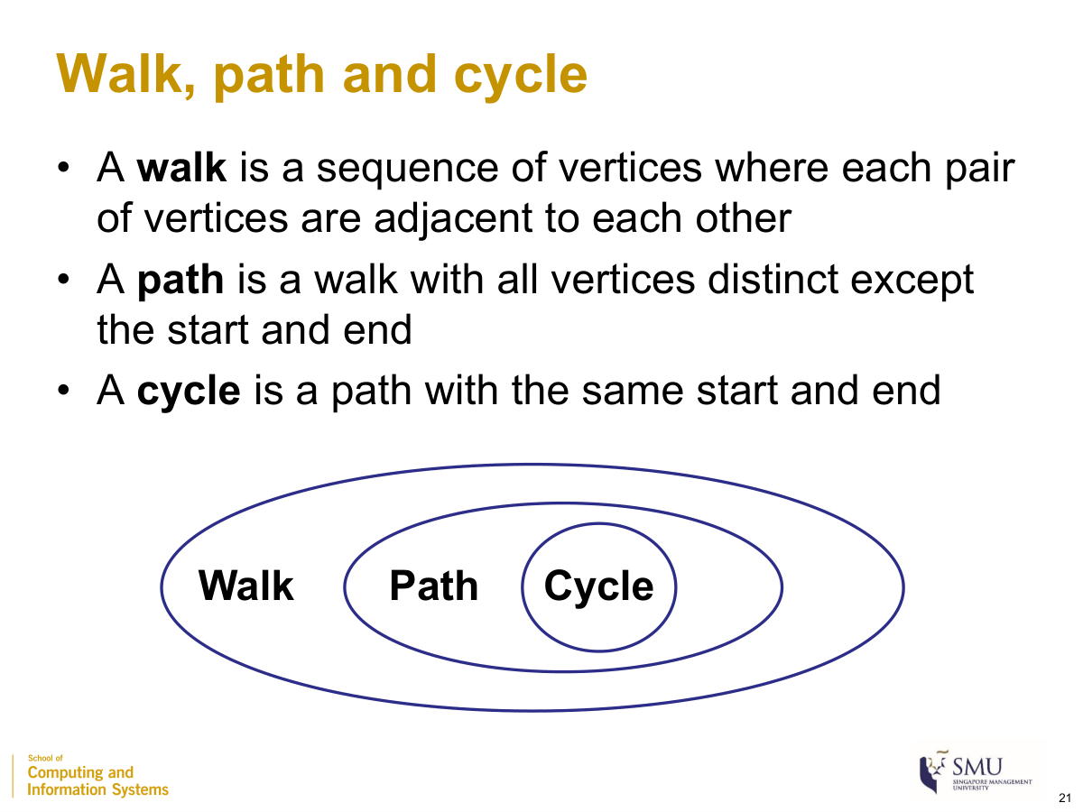
Walk ⊃ path ⊃ cycle (Session 1, slide 21)

Edges in a complete graph
$$|E|=\frac{n(n-1)}{2}$$
where
- $|E|$: number of edges
- $n$: number of nodes (vertices)
Example: $n=10⇒\frac{10⋅9}{2}=45$ edges.

Degree
$$deg(v)=\text{number of edges with }v\text{ as an endpoint}$$
where (directed graph)
- $\text{indeg}(v)$: number of edges pointing into v
- $\text{outdeg}(v)$: number of edges pointing out of v
Example: edges {(a,b),(a,c),(a,d),(b,c)} → deg(a)=3, deg(b)=2, deg(c)=2, deg(d)=1.

Degree and edges
v∈V​deg(v)=2 |E| (directed: ∑indeg(v)=∑outdeg(v)=|E|)
where
- v∈V​deg(v): total degrees, summed over all nodes
- $|E|$: number of edges (each edge is counted at both endpoints, hence $2|E|$)
Example: degrees 3+2+2+1 = 8 = 2 × 4 (Number of edges = 4). ✓

Weight and cost for a shortest path
For an unweighted graph the costs on all edges are treated as one; for a weighted graph the weight may be interpreted as a cost. (FAQ) when a higher weight means a stronger/closer tie, convert it:
$$\text{cost}=\frac{1}{\text{weight}}$$
where
- $\text{weight}$: edge weight (higher = stronger/closer tie)
- $\text{cost}$: traversal cost used by shortest-path algorithms (stronger tie ⇒ cheaper)
Example: weight 4 → cost 0.25; weight 1 → cost 1.0.

Distance of a path
distance(path)=e ∈ path​cost(e)
where
- $\text{cost}(e)$: cost of edge $e$ (= 1 for every edge in an unweighted graph)
- the shortest path between two nodes is the path with the minimum total distance
Example (weighted): a path with edge costs 1+3+1 = 5; an alternative costing 1+1+1 = 3 is shorter.

Storing a graph
- Adjacency matrix: $n×n$; entry $(i,j)=1$ if there is an edge from i to j (or stores the weight). Symmetric for undirected graphs; size $n^{2}$, so the slides call it adjacency matrix (sparse). A 1 on the diagonal = an edge from a node to itself (FAQ — self-loop).
- Adjacency lists: store, per node, only its neighbors — compact for the sparse graphs typical of social networks.

SESSION 2 — Social Networks as Graphs
Centrality measures are not in this session — see Session 5.

Graph types
- Bipartite graph $G=(U,V,E)$: two disjoint node sets; every edge crosses between them; none within a set.
- Ego-network: a focal node (the ego) with its neighbors and the edges among them.
- Heterogeneous information network (HIN): multiple node and edge types, with attributes.
- Co-occurrence graph: nodes linked when they appear together.

Ego-network size
$$\text{nodes}=d+1, \text{min edges}=d, \text{max edges}=\frac{d(d+1)}{2}$$
where
- $d$: degree of the ego (its number of neighbors)
- min edges = the star (ego to each neighbor); max edges = a complete graph on $d+1$ nodes
Example: $d=4$ → 5 nodes, from 4 edges (star) to 10 edges (complete).

Network diameter (small-world)
The diameter summarizes the shortest distances between all node pairs (taken as the average, the maximum, or a percentile). Social networks are small-world with a small diameter:
$$L ∝ logN$$
where
- $L$: average shortest distance between node pairs
- $N$: number of nodes
Common definitions of network diameter
– Average shortest distance among all pairs
– Maximum / 90th percentile shortest distance, etc.
Social networks tend to have a small diameter
A few celebrity (high-degree) nodes create shortcuts that keep $L$ small. Example (5-node graph, 10 pairs, distances 1,3,1,2,3,1,2,2,1,1, sum = 17): maximum diameter = 3; average = 17/10 = 1.7.

Power-law degree distribution
$$y ≈ a x^{-k}$$
where
- $x$: node rank by degree; $y$: the node’s degree
- $a$: scaling constant; $k>0$: the power-law exponent
A few celebrity nodes have very high degree, most other nodes have low degree — the 80-20 rule (~20% of nodes hold ~80% of connections).

Clustering coefficient ⭐
A global measure of how strongly connected triplets close into triangles. A connected triplet = three nodes with at least two edges (closed if it forms a triangle, open otherwise).
$$C=\frac{\text{number of closed triplets}}{\text{number of all triplets}}=\frac{3×\text{number of triangles}}{\text{number of all triplets}}$$
where
- closed triplet: a triplet whose three nodes are all connected (a triangle)
- all triplets: open + closed triplets
- the factor 3: each triangle contains 3 closed triplets (one centered on each node); range of $C$ is 0–1
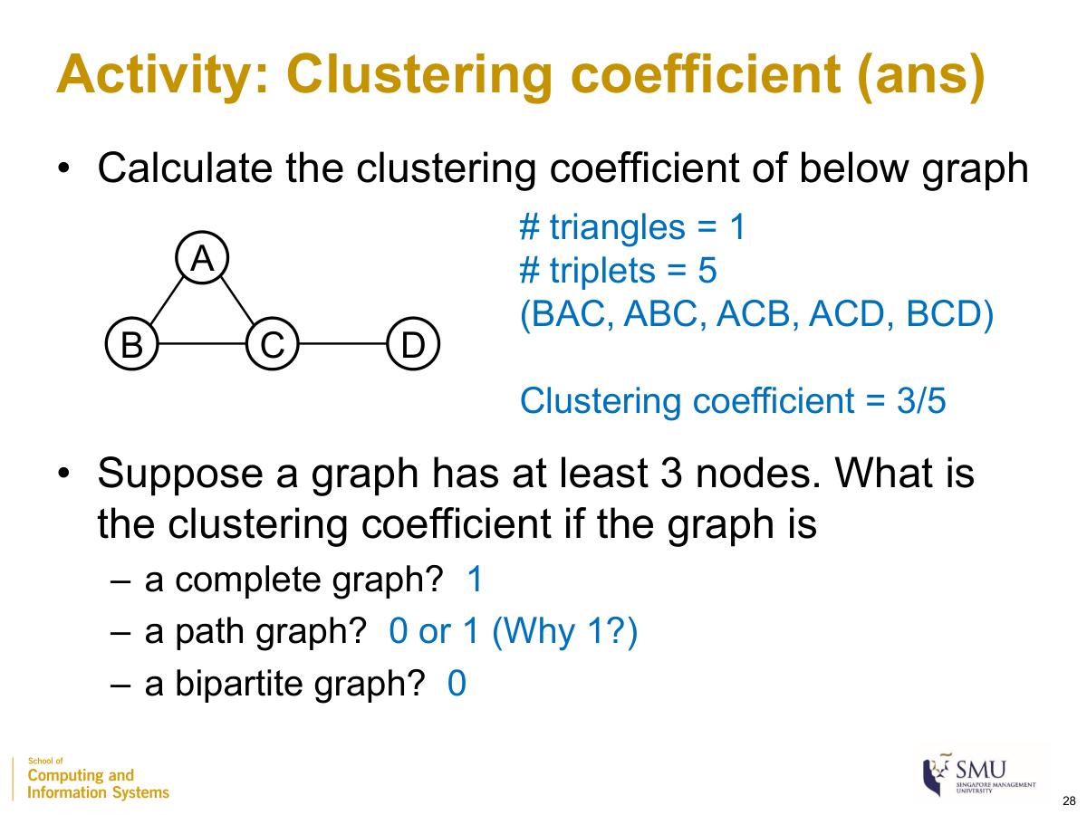
Clustering coefficient worked example (Session 2, slide 28)
Example (triangle A–B–C plus edge C–D): # triangles = 1; # triplets = 5 (BAC, ABC, ACB closed; ACD, BCD open) → $C=3/5=0.6$. Special cases (≥3 nodes): complete graph → 1; path graph → 0 or 1; bipartite graph → 0.

Preferential attachment (Barabási–Albert)
pu=duv​dv
where
- $p_{u}$: probability a new node links to existing node u
- $d_{u}$: current degree of u
- v​dv: total degrees of all nodes ($=2|E|$)
Example: $d_{u}=5$, total degrees = 14 → $p_{u}=5/14≈0.357$; a degree-1 node → $1/14≈0.071$.

Homophily ratio
$$h=\frac{\text{number of edges between same-class nodes}}{\text{total number of edges}}$$
where
- $h$: global homophily ratio, range 0–1
- “class”: a node attribute defined by the analyst (university, interest, …)
Example: 8 of 9 edges join same-university students → $h=8/9≈0.889$.

SESSION 3 — Social APIs
Conceptual session (no formulas). Demonstrated with the Reddit API: how a program requests data from a social-media service and how that data maps to node, edge and text data.

What is an API
API = Application Programming Interface — a collection of functions for building applications. A local client (your laptop) sends a parameterized request to an API provider, which returns a response containing data.
- Provider can be local or remote. Local example: len('hello world') is an API request to Python; the response is the integer 11. Remote example: a request to Reddit for a user’s profile, the posts/comments on a topic, etc.
- Endpoint = a unique location identifier used to communicate with the API. For remote services, endpoints are URL addresses (e.g. https://oauth.reddit.com/api/v1/me).
- APIs change frequently — names, parameters and responses can change at any time, so you must learn to read the API documentation.

API etiquette (rules)
- Don’t be abusive: strictly follow the provider’s use cases, policies, terms and conditions.
- Don’t be aggressive: respect rate limits (at most X calls in any Y-minute window). For Reddit the limit is 60 calls per minute.
- Abusive/aggressive behavior can get your account or IP banned.

Authentication vs authorization
- Authentication confirms a user’s identity (who you are).
- Authorization determines a user’s access rights to resources (what you may access).
- For a Reddit “script” app you register at preferences → apps, you receive an ID and a secret token (treat like passwords). Credentials are stored in mysecrets.py; the requests package sends the HTTP request.

Response: status code + JSON
The response carries a status code telling whether the request succeeded:
Code | Meaning
200 | success
401 | unauthorized (no/incorrect credentials)
403 | forbidden (correct credentials but no privilege)
404 | not found (incorrect endpoint)
500 | internal server error (temporary server issue)
The response content is in JSON format, accessed with response.json() and stored in Python containers (dictionaries, lists). Keys are mostly self-explanatory but usually undocumented — you map them to attributes manually.

Simple wrapper (reddit_wrapper.py)
Standard API steps (authenticate → authorize → check status → parse JSON) are bundled into two functions:
- reddit_api_init() — authenticates and obtains authorization; stores the token in a global headers used by later calls.
- reddit_api_call(endpoint, params) — sends the request, receives the response, and sleeps 1 second before returning (to stay under 60 calls/min). The prefix https://oauth.reddit.com/ is hard-coded, so only the rest of the endpoint is passed. Returns the status code if unsuccessful, or the JSON content if successful.

Use cases — node, edge and text data
Node data (an entity = a node, e.g. a user or a subreddit):
Target | Endpoint
A user’s profile | user/[USERNAME]/about (your own = api/v1/me)
A subreddit | r/[SUBREDDIT]/about
Edge data (a relationship = an edge):
- user–subreddit edge (a user posts in a subreddit) → crawl posts with r/[SUBREDDIT]/new (newest) or r/[SUBREDDIT]/hot (trending). Store records in a pandas dataframe.
- user–user edge (a user comments on another’s post) → get a post’s comments with comments/[POST_ID].
- Friends/followers are NOT public — they cannot be obtained without that user’s authorization.
Pagination for list responses: - limit — how many items to retrieve (default 25, maximum 100). - after — a bookmark: return items after a given reference, so you can fetch the next page beyond 100. Get the after reference from the current response and pass it to the next request.
Text data (posts and comments are obtained as a by-product of edge data; plus search):
- search endpoint with a q parameter (query keywords, a string ≤ 512 characters). Optional sort (ordering) and t (time window) parameters.
- Restrict to one subreddit with r/[SUBREDDIT]/search and restrict_sr=on.

SESSION 4 — Social Text Analytics

Vector space model (bag of words)
Each document is a vector over the vocabulary; each word = one dimension, value = its count. A set of documents is a corpus. Word order is ignored; vectors are high-dimensional and mostly zero.

Dot product
d1⋅d2=i​d1i d2i
where
- $d_{1i},d_{2i}$: the i-th component (word count) of document vectors $d_{1}$ and $d_{2}$
- a first cut at overlap, but biased toward longer documents
Example: $d_{1}=(1,1,1,1,1)$, $d_{2}=(1,1,1,2,1)$ → 1+1+1+2+1 = 6.

Length of a document vector
v=i​vi 2
where
- $v_{i}$: the i-th component of vector $v$
- $\left\|v\right\|$: length of the document vector (Euclidean norm), used for document-length penalization
Example: $v=(4,3)$ → $\sqrt{4^{2}+3^{2}}=\sqrt{25}=5$.

Cosine similarity ⭐
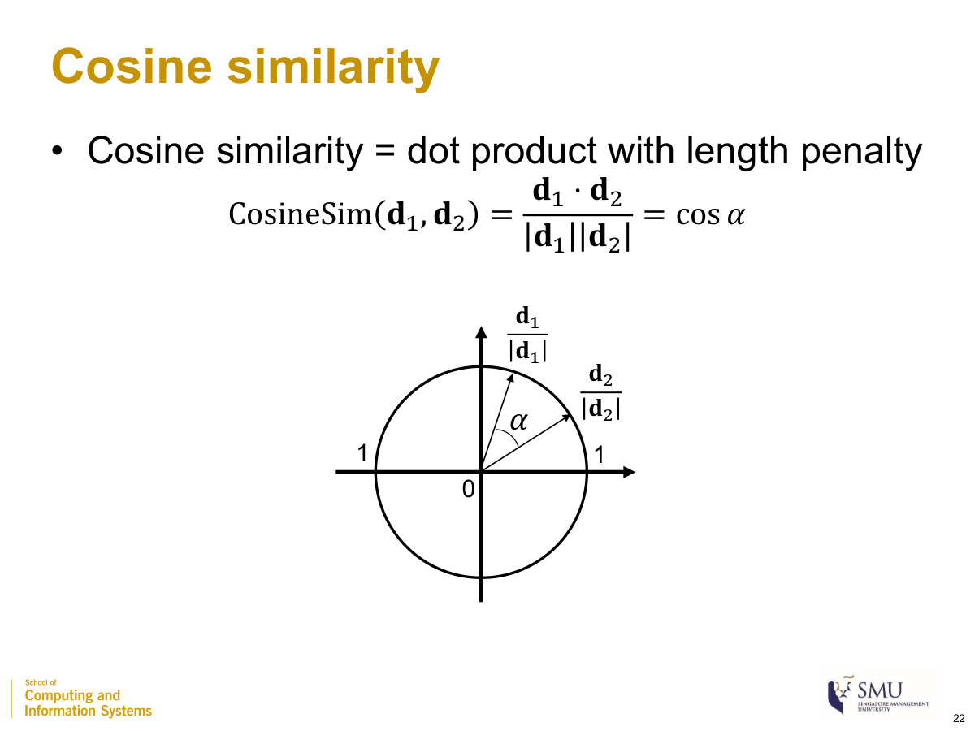
Cosine similarity = the dot product with a length penalty:
$$\text{CosineSim}(d_{1},d_{2})=\frac{d_{1}⋅d_{2}}{\left\|d_{1}\right\| \left\|d_{2}\right\|}=cosα$$
where
- $d_{1}⋅d_{2}$: dot product of the two document vectors
- $\left\|d_{1}\right\|,\left\|d_{2}\right\|$: their lengths
- $α$: the angle between the vectors; $cos0°=1$ (maximum similarity), $cos90°=0$ (minimum)

Cosine similarity = dot product with length penalty (Session 4, slide 22)
Example: $d_{1}=(1,1,1,1,1,0,0,0,0)$, $d_{2}=(1,1,1,0,1,0,0,0,0)$, $d_{3}=(1,1,1,1,1,1,1,1,1)$.
‖d1‖=√5≈2.24, ‖d2‖=2, ‖d3‖=3; d1·d2=4, d1·d3=5.
CosineSim(d1,d2) = 4/(2.24·2) = 0.89;
CosineSim(d1,d3) = 5/(2.24·3) = 0.74 (cosine fixes the dot-product’s length bias).

Term frequency, inverse document frequency, tf-idf
$$\text{tf-idf}(w,d)=\text{tf}(w,d)×\text{idf}(w)$$
where
- $\text{tf}(w,d)$: term frequency = number of times word w appears in document d (importance within d)
- $\text{idf}(w)$: inverse document frequency — smaller for words appearing in more documents (importance across the corpus). The slides give no idf equation; the cited Wikipedia form is $\text{idf}(w)=log\frac{N}{df(w)}$ with $N$ = number of documents, $df(w)$ = number containing w.
Example: corpus of $N=4$. “analytics” in all 4 docs → idf $=log(4/4)=0$ ⇒ tf-idf = 0 regardless of count. “exciting” in 1 doc → idf $=log4≈0.602$; tf = 1 ⇒ tf-idf ≈ 0.602.

Preprocessing
- Stop words: very frequent, low-meaning words — usually removed; list is subjective (motivates idf).
- Stemming (fixed rules, fast, less accurate) vs lemmatization (dictionary + part of speech, accurate, costlier).
- Tokenization = splitting into words. n-grams = treating n consecutive words as a unit (FAQ).

Sentiment analysis
Types: polarity (pos/neg), subjectivity vs objectivity, aspect-based opinion mining. Approaches: lexicon-based vs machine-learning-based (preprocess → feature engineering with tf/idf → train with labels → predict).

Topic modeling
Each topic = a multinomial distribution over words; each document = a multinomial distribution over topics. Probability of an observed set of words from a topic:
P=i​pi×k!
where
- $p_{i}$: probability of the i-th observed word under the topic
- $k$: number of word slots; $k!$ accounts for all orderings
Example: topic Party = {Sushi 0.3, Beer 0.7}, document {Sushi 1, Beer 1}: $P=0.3×0.7×2!=0.42$; under topic Food {Sushi 0.3, Beer 0.1}: $0.3×0.1×2!=0.06$ → document is “Party”. Learned by LDA and BERTopic.

SESSION 5 — Social Influence (Centrality)
Simple centrality measures (degree, closeness, betweenness) treat all nodes equally; recursive centrality measures (eigenvector, PageRank) weight a node by the importance of its neighbors.

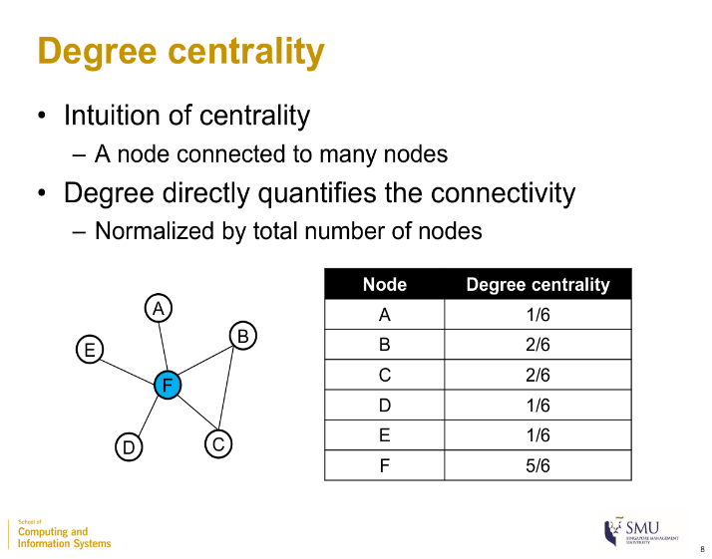
Degree centrality
$$C_{deg}(u)=\frac{deg(u)}{|V|}$$
where
- $deg(u)$: number of edges incident to u
- $|V|$: total number of nodes (the slides normalize by the total number of nodes)

Degree centrality on a star graph (Session 5, slide 8)
Example (star, hub F): F = 5/6; each leaf = 1/6. (In the activity below, B = 3/6, F = 3/6. Use the denominator the figure shows; some textbooks use $|V|-1$.) Directed graphs use in-degree or out-degree. Use when: a fast result / nodes that directly reach many others.

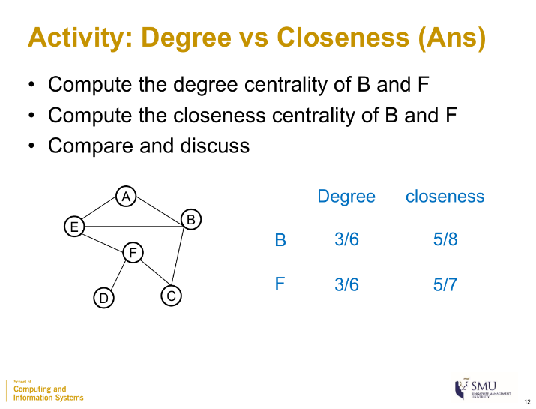
Closeness centrality
Cclose(u)=|V|-1v∈V​d(u,v)
where
- $|V|-1$: number of other nodes
- $d(u,v)$: shortest-path distance between u and v
- the denominator v​d(u,v): total shortest distance from u to all others (so $C_{close}$ is the reciprocal of the average shortest distance)
Example: node B = 5/8; node F = 5/7. B and F have equal degree (3/6) but F is closer on average. Use when: finding who can influence a large proportion of the network most quickly.

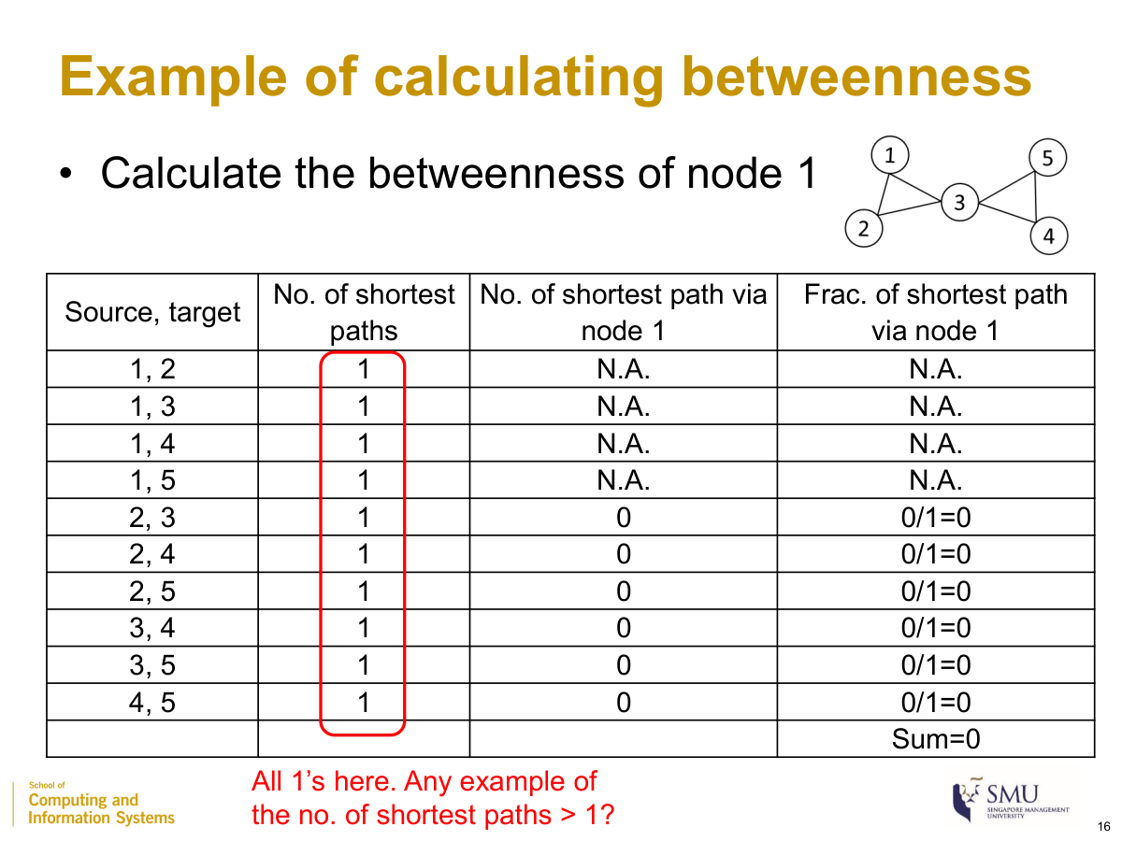
Betweenness centrality
betweenness(u)=s≠u≠t∈V​σst(u)σst
where
- $σ_{st}$: number of shortest paths from s to t
- $σ_{st}(u)$: number of those shortest paths that pass through u
- the sum runs over all pairs $s,t$ with $s≠u≠t$ (pairs involving u are excluded → “N.A.”)

Betweenness calculation example (Session 5, slide 16)
Example (two triangles {1,2,3} and {3,4,5} joined at node 3): every pair has a single shortest path ($σ_{st}=1$). For node 1 none of the other pairs’ paths pass through it → betweenness(1) = 0. For node 3 the four pairs {1,2}×{4,5} all pass through it → betweenness(3) = 4. Note: if there is one shortest path the fraction is 0 or 1; if several, use the fraction. A high value can mean a genuine bridge or a node on the periphery of two groups. Use when: finding who controls the flow of information between groups.

Eigenvector centrality (recursive)
xu ∝ v∈IN(u)​xv ⇒ A⊤x=λx
where
- $x_{u}$: centrality score of u (it is high if pointed to by high-scoring nodes)
- $IN(u)$: set of in-neighbors of u (nodes with a link to u)
- $A^{⊤}$: transpose of the adjacency matrix; $λ$: an eigenvalue ($x$ is an eigenvector of $A^{⊤}$)

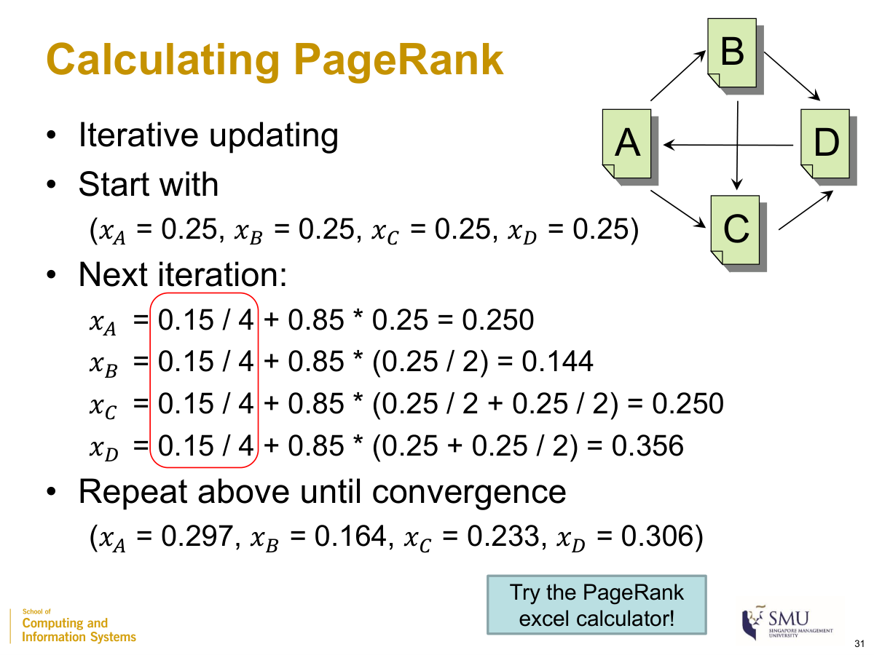

PageRank ⭐ (a variant of eigenvector centrality)
xu=1-α|V|+αv∈IN(u)​xvoutdeg(v)
where
- $x_{u}$: PageRank score of u
- $α$: damping factor, $α=0.85$
- $|V|$: total number of nodes; $\frac{1-α}{|V|}$ is the teleportation probability spread over all nodes
- $IN(u)$: in-neighbors of u; $\text{outdeg}(v)$: number of out-links of v (each node splits its score equally among its out-links)
- a page with no out-link distributes its score to all nodes
Calculating PageRank — one iteration (Session 5, slide 31)
Example (edges A→B, A→C, B→C, B→D, C→D, D→A; out-degrees A=2, B=2, C=1, D=1; $\frac{1-α}{|V|}=\frac{0.15}{4}=0.0375$; start all 0.25): $x_{A}=0.0375+0.85(0.25)=0.250$; $x_{B}=0.0375+0.85(0.25/2)=0.144$; $x_{C}=0.0375+0.85(0.25/2+0.25/2)=0.250$; $x_{D}=0.0375+0.85(0.25+0.25/2)=0.356$. Iterate to convergence → A=0.297, B=0.164, C=0.233, D=0.306 (independent of the start).

Which centrality to use
Goal | Use
Influence a large proportion of the network most quickly | Closeness
Fast result / direct reach to many | Degree
Control the flow of information between groups | Betweenness
Importance derived from important neighbors | Eigenvector / PageRank

SESSION 6 — Social Communities
A community is more densely connected internally than with the rest of the network. Detection = clustering vertices. Families: agglomerative (bottom-up, merge) and divisive (top-down, split). Two design questions: how to merge/split and when to stop.

Expected edges (for modularity)
$$E_{ij}=\frac{k_{i} k_{j}}{2m}$$
where
- $E_{ij}$: expected number of edges between i and j if the m edges are rewired randomly while keeping the same node degrees
- $k_{i},k_{j}$: degrees of nodes i and j
- $m$: number of edges in the network; 2m=i​ki

Modularity matrix
$$B_{ij}=A_{ij}-\frac{k_{i} k_{j}}{2m}$$
where
- $A_{ij}$: observed adjacency entry (1 if an edge between i and j, else 0)
- $\frac{k_{i}k_{j}}{2m}$: expected edges $E_{ij}$

Modularity Q ⭐
Q=12mi,j​Aij-ki kj2mδ(si,sj)
where
- $A_{ij}$: observed edge; $\frac{k_{i}k_{j}}{2m}$: expected edge
- $k_{i},k_{j}$: node degrees; $m$: number of edges
- $δ(s_{i},s_{j})$: 1 if i and j are in the same community, else 0
- $s_{i}$: community assignment of node i; range of $Q$ is −1 to 1 ($Q>0$ ⇒ within-community edges exceed random)
Shortcut: $Q=\frac{1}{2m}∑B_{ij}$ over pairs in the same community only. $Q$ depends on the community assignment; all nodes in one community ⇒ $Q=0$.
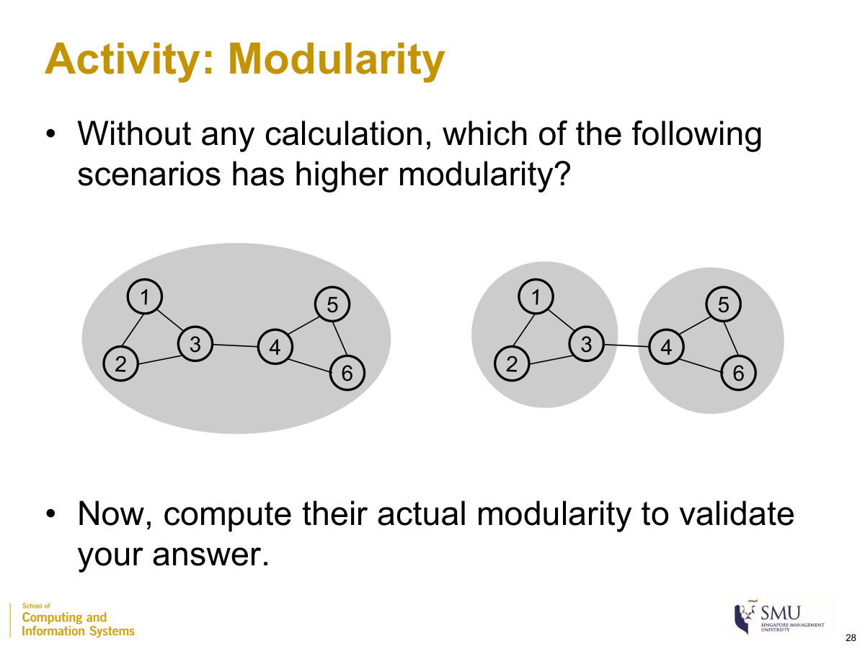
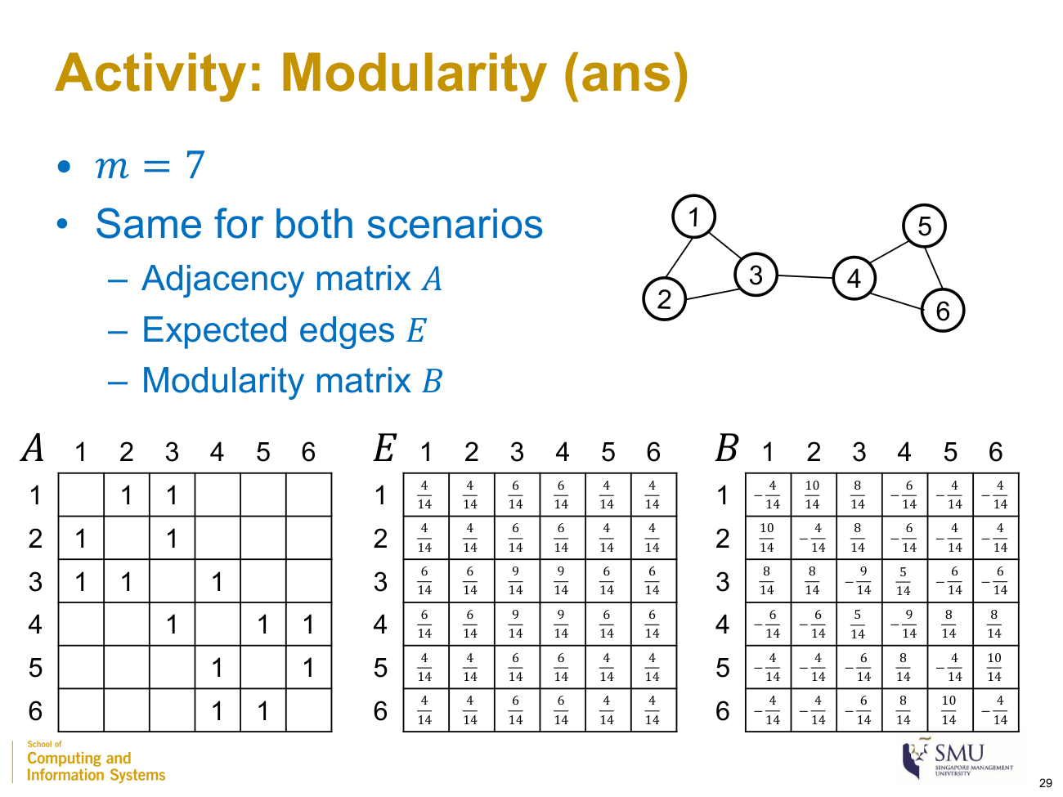
Graph: 6 nodes — two triangles {1,2,3} and {4,5,6} joined by the bridge edge (3,4). $m=7$ so $2m=14$; degrees $k=(2,2,3,3,2,2)$. The matrices A, E, B are the same for both scenarios — only the community assignment $δ$ differs.
Step 1 — Adjacency matrix A $A_{ij}=1$ if there is an edge between i and j, else 0.
Step 2 — Expected edges E $E_{ij}=\frac{k_{i}k_{j}}{2m}$. With $2m=14$, the numerators $k_{i}k_{j}$ are (each entry ÷ 14):
Step 3 — Modularity matrix B = A – E subtract element-wise, $B_{ij}=A_{ij}-\frac{k_{i}k_{j}}{14}$ (each entry ÷ 14):
(e.g. $B_{12}=1-\frac{2⋅2}{14}=\frac{10}{14}$; $B_{14}=0-\frac{2⋅3}{14}=-\frac{6}{14}$.) A useful check: every row of B sums to 0.
Step 4 — Apply δ and sum (slide 30): Q=12mi,j​Bij δ(si,sj). The δ matrix is a mask that keeps only the B entries whose two nodes are in the same community (δ=1) and zeros out the rest (δ=0). So the only thing that changes between scenarios is which entries of B you add up.
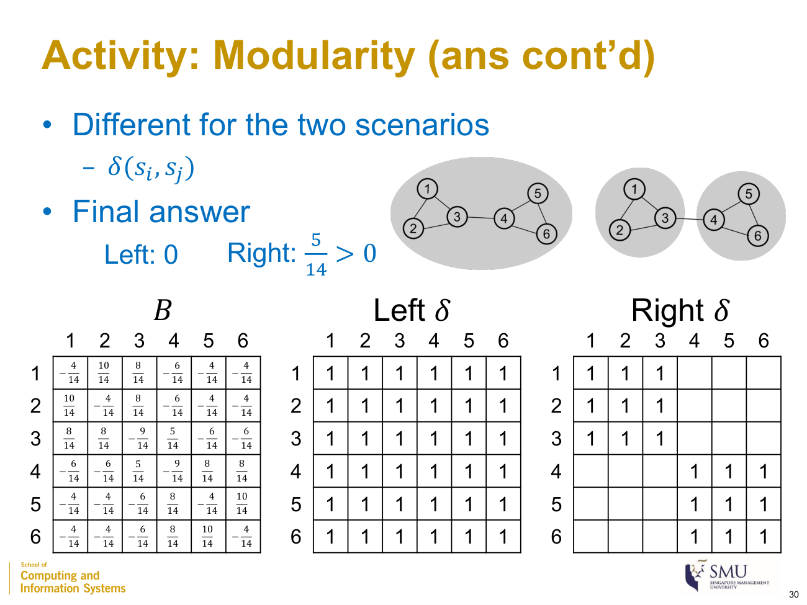
δ mask for each scenario, with the final answers (Session 6, slide 30)
- Left scenario — one community (δ = all 1s): keep every B entry. Because each row of B sums to 0, the grand total is 0 → $∑B_{ij}δ=0$ → $Q_{\text{Left}}=\frac{1}{14}⋅0=0$.
- Right scenario — two communities {1,2,3} | {4,5,6} (δ = block-diagonal): keep only the two 3×3 blocks of B. Summing those numerators:
  - block {1,2,3}: $(-4+10+8)+(10-4+8)+(8+8-9)=14+14+7=35$
  - block {4,5,6}: $(-9+8+8)+(8-4+10)+(8+10-4)=7+14+14=35$
  - total = 35 + 35 = 70 → $∑B_{ij}δ=\frac{70}{14}=5$ → $Q_{\text{Right}}=\frac{1}{2m}⋅5=\frac{1}{14}⋅5=\frac{5}{14}≈0.357$.
Since $Q_{\text{Right}}=5/14>Q_{\text{Left}}=0$, the split into two triangles is the better community structure.

Edge betweenness — Girvan–Newman (divisive)
betweenness(e)=s≠t​σst(e)σst
where
- $σ_{st}$: number of shortest paths from s to t
- $σ_{st}(e)$: number of those shortest paths that pass through edge e
- bridge edges between communities carry the most shortest paths → highest betweenness
Example (same 6-node graph): bridge edge (3,4) lies on all 9 shortest paths between the two triangles → betweenness = 9; an internal edge (1,2) → betweenness = 1. The algorithm removes the highest-betweenness edge first. Agglomerative (modularity-based): start from singletons, repeatedly merge the pair of communities that most increases $Q$, stop when no merge increases $Q$ (or the target count is reached).

SESSION 7 — Social Similarities
A social similarity score $S(u,v)$ (also node proximity) measures how similar two nodes are. Pairwise = two specific nodes; single-source = given a query node, score all nodes and take top-k. $N(v)$ = neighbor set of v; $|N(v)|$ = degree.
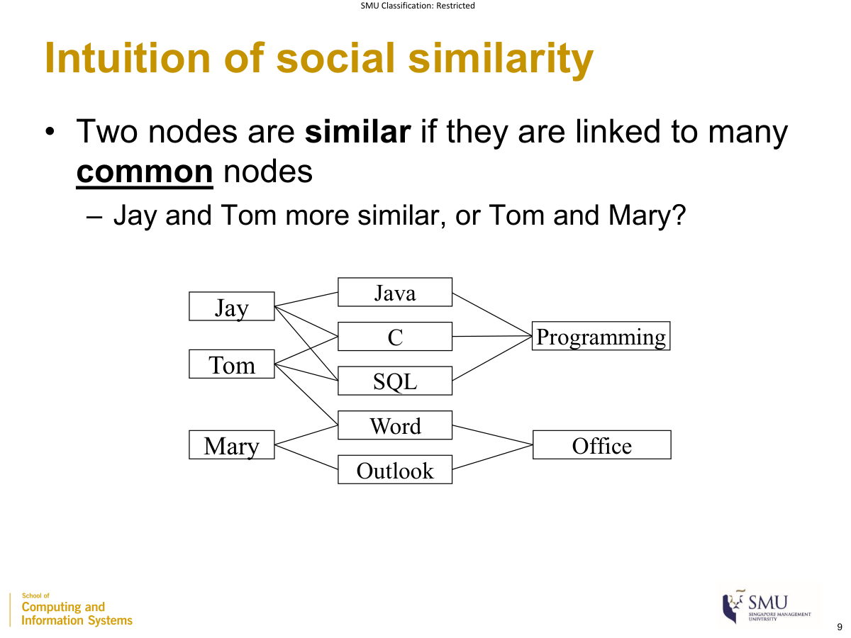
Skills graph used for Jaccard and Adamic–Adar (Session 7, slide 9)

Jaccard similarity
$$\text{Jaccard}(a,b)=\frac{|N(a)∩N(b)|}{|N(a)∪N(b)|}$$
where
- $N(a)∩N(b)$: common neighbors of a and b (numerator = their count)
- $N(a)∪N(b)$: all neighbors of a or b (the union normalizes the count); range 0–1
Example: Jay and Tom — common neighbors = 2, union = 4 → 0.5; no common neighbor → 0.

Adamic–Adar
AA(a,b)=v ∈ N(a)∩N(b)​1log|N(v)|
where
- $v$: a common neighbor of a and b
- $|N(v)|$: degree of v; a more popular common neighbor (larger $|N(v)|$) contributes less (“less useful”, behaves like a stop node (FAQ))
- $log$: natural log; the score normalizes common neighbors by the neighbors’ influence and is not bounded by 1
Example: common neighbors {SQL (deg 3), Word (deg 4)} → $\frac{1}{ln3}+\frac{1}{ln4}=0.910+0.721=1.63$. Only {Word (deg 4)} → 0.721. (Jaccard weights all common neighbors equally; Adamic–Adar discounts by degree.)

SimRank (recursive)
S(a,b)=C|N(a)| |N(b)|a'∈N(a)​b'∈N(b)​S(a',b')
where
- $S(a,b)$: similarity of a and b; base case $S(a,a)=1$
- $C$: damping factor, typically 0.85
- $N(a),N(b)$: neighbor sets; $|N(a)| |N(b)|$ = number of neighbor pairs (averaging factor)
- $a^{'},b^{'}$: a neighbor of a and a neighbor of b (two nodes are similar if linked to similar nodes)
Example (4-node diamond A–C–B, A–D–B, C–D; C=0.85; iteration 0 = 1 if a=b else 0): $S_{1}(A,B)=0.85⋅\frac{1+0+0+1}{4}=0.425$; $S_{1}(A,C)=0.85⋅\frac{1}{6}=0.142$. (SimRank: one score per pair, must start from the base case; PageRank: per node, any start.)

Graph edit distance
$$\text{GED}(G_{1},G_{2})=min\left(\text{number of edit operations to transform }G_{1}→G_{2}\right)$$
where
- edit operations: vertex/edge insertion, deletion, or substitution
- smaller GED = more similar graphs
Example: one edge deletion + one vertex substitution → GED = 2.

Comparison
Measure | Based on | Range
Jaccard | common neighbors (∩ / ∪) | 0–1
Adamic–Adar | common neighbors discounted by influence | 0 to ∞
SimRank | similar neighbors (recursive) | 0–1
GED | minimum edit operations (whole graph) | 0 to ∞ (distance)

SESSION 8 — Word & Network Embedding

Why embeddings
The vector space model has Issue 1 — curse of dimensionality (high-dimensional, sparse) and Issue 2 — inadequate semantics (related words look unrelated). A word embedding maps each word to a low-dimensional vector (e.g. 100 or 200 dims) where similar words are close; dimensions carry hidden meaning (FAQ — latent). Core idea: similar/related words appear in similar contexts.

Word2Vec — SkipGram
SkipGram predicts the context words from the target word; context = the words within a window size before and after the target. (CBOW, the reverse, is not in this deck.)

Context–target pair count example ⭐
How many context-target pairs can be formed in a sentence of 20 words, assuming a window size of 5 words?
$$\text{pairs}=35+100+35=170 \left(\text{shortcut: }N⋅2m-m(m+1)\right)$$
where
- $N$: sentence length (number of words) — here 20
- $m$: window size per side — here 5
- the slide counts directly: first 5 words give 5+6+7+8+9 = 35; middle 10 give $10×(5+5)=100$; last 5 give 9+8+7+6+5 = 35
- the closed form $N⋅2m-m(m+1)=20⋅10-30=170$ is a shortcut (not on the slide)
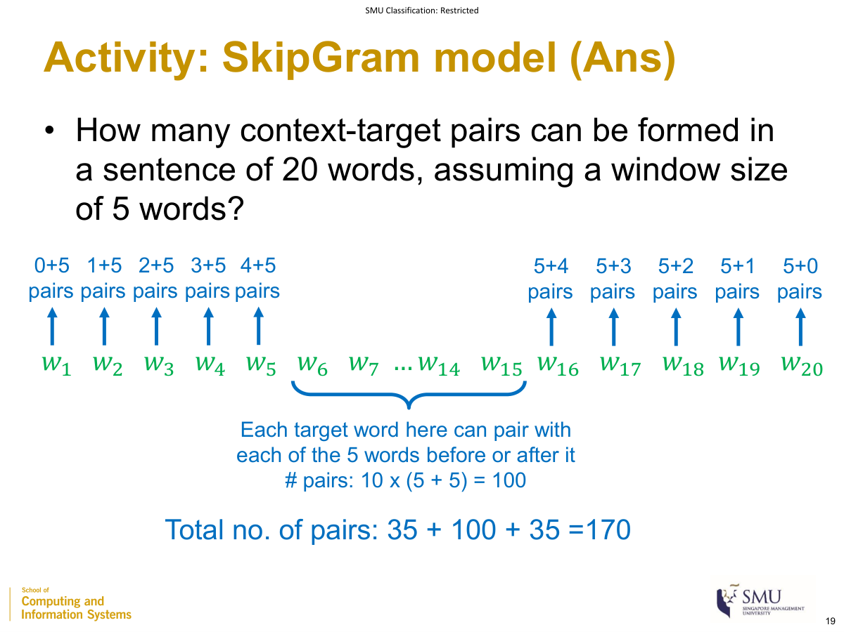
Counting SkipGram context–target pairs → 170 (Session 8, slide 19)

Cosine similarity in embedding space
$$cos(a,b)=\frac{a⋅b}{\left\|a\right\| \left\|b\right\|}$$
where
- $a,b$: two embedding vectors (of words or nodes)
- $a⋅b$: dot product; $\left\|a\right\|,\left\|b\right\|$: their lengths; range −1 to 1 (used to find closest words/nodes, e.g. “cos = 0.78”)
Example: $a=(1,2,2)$, $b=(2,0,1)$ → dot = 4, ‖a‖ = 3, ‖b‖ = √5 ≈ 2.236 → 4/6.708 = 0.596.

Document vector aggregation
Word2Vec gives one vector per word; to get one vector per document, average the word vectors:
$$\text{doc vector}=\frac{1}{n}\sum_{i=1}^{n}{w_{i}}$$
where
- $w_{i}$: embedding vector of the i-th word in the document
- $n$: number of words (averaging keeps a fixed dimension and is length-normalized)
Method | Plausible? | Reason
Concatenation | No | variable dimension
Sum | Yes | fixed dimension, but longer documents give larger values
Average | Yes (best) | fixed dimension and length-normalized
Example: word vectors (1,0,2), (0,3,1), (2,1,0) → sum (3,4,3); average (1, 1.33, 1).

Network embedding — DeepWalk

Reuse word embedding by analogy: node ↔ word, random walk ↔ sentence, neighboring/reachable nodes ↔ context words. 1. From each node, perform K random walks of some given length L. 2. Treat each random walk as a sentence. 3. Feed the walks into Word2Vec SkipGram. (Recommended $K≈L≈50$ (FAQ); weighted/directed graphs handled at the random-walk stage (FAQ).)
Using node vectors: social influence → regression; community detection → clustering; node/social similarity → cosine similarity; node classification → SVM / logistic regression.

MASTER FORMULA CHEAT-SHEET
# | Formula | Meaning | Session
1 | $$|E|=n(n-1)/2$$ | edges in a complete graph | 1
2 | $$∑deg(v)=2|E|$$ | degree and edges | 1
3 | $\text{cost}=1/\text{weight}$ (FAQ) | weight as cost | 1
4 | nodes $=d+1$, max edges $=d(d+1)/2$ | ego-network size | 2
5 | $$L∝logN$$ | small-world diameter | 2
6 | $$C=3×\text{triangles}/\text{all triplets}$$ | clustering coefficient | 2
7 | pu=du/v​dv | preferential attachment | 2
8 | $$h=\text{same-class edges}/\text{total edges}$$ | homophily ratio | 2
9 | $$\text{tf-idf}=\text{tf}×\text{idf}$$ | term weighting | 4
10 | $$\text{CosineSim}=\frac{a⋅b}{\left\|a\right\|\left\|b\right\|}$$ | document / embedding similarity | 4,7,8
11 | P=i​pi×k! | topic model | 4
12 | $$C_{deg}=deg(u)/|V|$$ | degree centrality | 5
13 | Cclose=(|V|-1)/v​d(u,v) | closeness centrality | 5
14 | $$\text{betweenness}(u)=∑σ_{st}(u)/σ_{st}$$ | betweenness centrality | 5
15 | $$x_{u}=\frac{1-α}{|V|}+α∑\frac{x_{v}}{\text{outdeg}(v)}$$ | PageRank ($α=0.85$) | 5
16 | $$Q=\frac{1}{2m}∑(A_{ij}-\frac{k_{i}k_{j}}{2m})δ$$ | modularity | 6
17 | $$\text{betweenness}(e)=∑σ_{st}(e)/σ_{st}$$ | edge betweenness | 6
18 | $$\text{Jaccard}=\frac{|N(a)∩N(b)|}{|N(a)∪N(b)|}$$ | node similarity | 7
19 | $$\text{AA}=∑1/ln|N(v)|$$ | Adamic–Adar | 7
20 | $$S(a,b)=\frac{C}{|N(a)||N(b)|}∑∑S(a^{'},b^{'})$$ | SimRank | 7
21 | pairs $=35+100+35=170$ | SkipGram pair count | 8
22 | doc vector $=\frac{1}{n}∑w_{i}$ | document embedding (average) | 8

